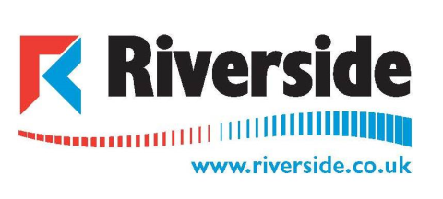

Ventilation Ductwork Improver
The Company: Riverside represents 40+yrs of innovation, proven success and professional delivery in giving you total control over your environment. We offer consulting, planning, design, manufacture, installation and maintenance in all aspects of commercial and industrial:
Cooling Heating Ventilation Electrical

The Job: We are currently looking to employ – A trainee, ductwork erector/sheet metal worker/fabricator.
The applicant should ideally have an interest, or preferably some engineering experience and be happy to work, both on site and within our workshop under the supervision of our trained and qualified technicians.
The applicant should be local to the Bridgend area, have a valid driving licence with own vehicle, and be able to work outside of our ‘normal working hours’ or away if and when required.
Due to the nature of our clients, the applicant must have a clean criminal record and be prepared to be CRB checked.
We would offer ongoing training and rates of pay dependant on experience.

.Apply by email with your C.V and supporting information to:
Aimee John – Managing Director aimee.john@riverside.co.uk

